FilmStar 20K Pro Scanner Documentation

Walde, Inc. – July 28, 2026

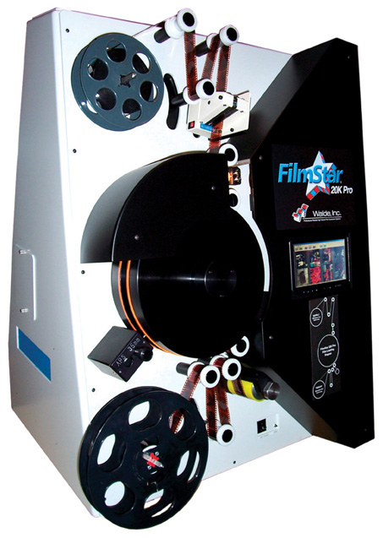


Walde FilmStar 20K Pro Quick Start Guide
Power On/Off, Batch Scanning Procedures / Exceptions

POWER ON / SHIFT START PROCEDURE
-------------------------------------------------------

- TURN ON FSImage20K PC (wait a few seconds)
- TURN ON FilmStar 20K Pro Scanner (switch in Right Rear)
- MAKE SURE Light Source Switch is ON (front of scanner)
- OPTION: TURN ON FSProduct20K Pro PC
- Logon to FSImage20K PC as Administrator with pass waldepass (if not auto login)
  - FSEnhance.exe and FSImage20k.exe applications automatically start
- OPTION: Logon to FSProduct20K Pro PC as Administrator with pass waldepass
  - FSProduct.exe application automatically starts
- Clean PTR Rollers (2) and Main Drive Roller (1) with sticky tape
- Wait 5 min. for warm-up. Do Uniformity Correction (View→Uniformity Correction)

BATCH SCANNING
---------------------------

- Load Film (Set Film Format to 35mm or APS)
- Apply Tension (Click + Button)
- Begin Batch (Click Green Button)
  - Enter Batch Number
  - OPTION: Confirm Products (CD, INDEX, PRINT) and Brand
  - Click OK to Start Batch
- Click Yes at end of Batch to Process the last roll
- Unload Film
- Calibrate Main Camera when Indicated by Software

BATCH SCANNING KNOWN EXCEPTIONS
-------------------------------------------------------------

- Scanner may lose film control or hang-up or show problem images. If so, Exit the application, click the RESET button on the front of the scanner, and then restart the FSImage software by double-clicking the icon on the desktop.

- If Restarting the software does not work to cure a scanner problem, then
  - Shutdown the FSImage20K PC PC
  - Shutdown the FilmStar 20K Pro Scanner
  - TURN ON FSImage20K PC PC
  - TURN ON FilmStar 20K Pro Scanner

POWER OFF PROCEDURE
-------------------------------------

- OPTION: Shutdown FSProduct20K Pro PC
- Shutdown FSImage20K PC
- Shutdown the FilmStar 20K Pro Scanner
----------------------------------------------------------------------
Walde FilmStar 20K Pro Scanner INSTALLATION
----------------------------------------------------------------------

1) Install on solid, non-vibration table. Switch drum into 35mm mode.

2) Remove back cover, free tie-wrapped cables (CL1, CL2, PRESCAN, USB).

3) Unscrew lamp access (2 screws, not the single screw for the bundle) and check that lamp is all the way down and did not vibrate to a different position. Replace screws.

4) Connect all cables to PC (4 cables mentioned in 2 above plus VIDEO, MCOM, BCOM).

5) Check all connections....POWER UP! (Remember, the scanner/FilmStar board must be reset AFTER the PC boots). You can power pc and then power scanner OR power scanner, power PC, and then hit the Filmstar reset button. Note that FSImage20K and FSEnhance s/w will start.

6) REMOVE front cover (carefully) and verify prescan lens f-stop is at F8. It is an f2 lens so you have f2, f4, f5.6, f8, f11, f16, f22. The f8 is right in the middle and will be 3 in from either extreme.

7) Default Bail Arm motor polarities are set for supply spools OVER (emulsion out) and takeup spools UNDER (emulsion out). Open c:\windows\FSImage20K.ini file settings and change the BailSupplyDir/BailTakeupDir settings in the [MotorSetup] section if your lab is different. Exit and Restart the FSImage20K application if any settings were changed.

8) Load film according to attached image loading diagram but modify for your labs’ difference in supply/takeup spooling. Apply tension and verify film control exists.

9) Align BAR CODE READER by going to Edit->Advanced->Barcode Reader Diagnostics->Set Barcode Constant Scan Mode. Position bar code in front of beam and align bracket angle with Allen wrench. Tighten. Put Barcode Reader back in Host Mode. Replace scanner front cover.

10) Perform lamp cal (View->Lamp Levels....must clear film path) to verify light/camera alignment HELD during transport. Note the percentages BEFORE you do the calibration. The new percentages should be very close to the original percentages.

11) Perform Uniformity Correction (View->Uniformity Correction..........must clear film path) to upload pixel correction data to camera for perform CCD line uniformity. This will be done automatically at the end of the first batch scanned after the application starts and then every 10 batches based on CalibrateInterval setting in [Camera] section of FSImage20k.ini file. This should be done manually after transport of unit and after changing to a new BULB. Sometimes this process fails and you have to restart application and maybe even shut off scanner as well and then restart the application.

12) Configure TCP/IP network settings and WORKGROUP and verify that FSEnhance is configured to talk to the FSProduct Images directory (if using FSProduct).

13) Start Batch (make sure AUTO INC ROLL NUM is not checked) and Scan LIVE film to perform frame gap alignment by bringing up Edit->Advanced->Frame Alignment while film is scanning. Adjust to get edge of black frame gap on each side of image and take difference to calculate encoder center point. You should have about 600 encoder counts between the extremes. Do the same for APS once you scan APS (if scanner is configured for APS mode).

14) Possibly adjust entry and exit drum guide rollers to remove black lines in APS mode.

15) Make a master correction (Edit->Master Color Correction) to obtain desirable color results.
--------------------------------------------------------------------
Walde FilmStar 20K Pro Scanner OPERATION
--------------------------------------------------------------------

1) Load Film
2) Apply Tension
3) Cue starting splice code to be before prescan gate and click on GREEN Begin Batch button. Enter Batch Number. Set Number Rolls to Scan (usually set to ALL and left alone but can be set to 1 or whatever if you are just rescanning 1 or a few rolls). Set Product Output and Brand (Usually set once and left alone). Set Frame Detection Mode (usually set to notch and left alone). Set Scan Resolution and Film Type (usually set to Medium/4Base and left alone).

*Note that During Batch scanning, if the Splice or FID code is not read, the film is backed up to a viewing position so that the operator may enter in proper code in a special dialog that pops up during this situation.

**Note that during batch scanning, you may see the scanner back up as it collects data on new film types/dx codes up until there are 200 frames in the frame database for each of the film types.

***Set DefaultDxCode=0 in [Setup] section of INI file if do not want a default channel for failed DX (this will cause scanner to find the best film curve match for a film but will also cause a backup). Set this to 99999 so that on a failed DX, the scanner will use 99999 and not back up.

4) When Batch Ends and Take-up arms drop - a dialog is presented to operator to confirm that the last roll was properly scanned and should be sent over to the Product Server (operator normally selects YES unless batch ended prematurely due to lack of leader OR something else caused film tension to be lost).

*Note that Automatic Main Camera Lamp Pixel Correction and Lamp Cal are performed at the end of every 10 batches (CalibrateInterval setting in [Camera] section of FSImage20k.ini file).

**Note that the prescan camera automatically calibrates itself many times during batch scanning (you may see system stop and back up to calibrate prescanner as the lamp ages).

----------------------------------------------------------------------
Walde FilmStar 20K Pro Scanner MAINTENANCE
----------------------------------------------------------------------

1) Filters - a) lamp fan inlet filter on side of scanner....keep clean. b) Film cleaner filter on back side of cleaner. Cleaner must be removed to change or clean (there are spare filters taped to scanner face plate inside scanner).

2) PTR Rollers, Drive Roller, and DRUM - Operators should roll sticky tape on the 2 PTR and the 1 main Drive roller to keep clean. Do so at the beginning of every SHIFT. The large DISCS of the DRUM should be wiped clean with an alcohol pad on a WEEKLY basis to make sure that no small rubber shavings or particles/hairs are stuck to surface and showing up in image area on final positive images.

3) Diffusers - Prescan and Scan Diffusers should be blown WEEKLY with low pressure compressed air to keep dust/particles from collecting on filters.

4) Lamp - Good for about 150 Hours. The automatic Pixel Correction / Lamp Cal which is performed every 10 batches and will inform the operator when the lamps are getting low. Change lamp at that time (make sure to position bulb all the way down in holder) and perform a manual Uniformity Correction (View->Uniformity Correction). MUST USE ONLY USHIO EKE BULBS.

